A Sustainable Electric Bicycle Scheme for Edinburgh
  - Benjamin de Sousa, Alexandros Zachakos, Todd House & Nolan Willoughby
  - MMCS Consultancy Project

Contents
1 Introduction 3
1.1 Historical Context 3
1.2 Objectives 3
1.3 Deliverables 3
2 Modelling Approach 4
2.1 Assumptions 4
2.2 General Sets and Notation 4
2.2 Base Model 4
2.2.1 Parameters 4
2.2.3 Constraints 4
2.2.4 Objective Function 4
2.3 Extended Model 4
2.3.1 Parameters 4
2.3.2 Variables 4
2.3.3 Constraints 4
2.3.4 Objective Function 4
3 Results 4
4 Conclusion 4
5 References 4
6 Appendix 5

1 Introduction
The city of Edinburgh is comprised of many winding and tight streets befitting its ancient origins. As such it is well serviced by a host of public transport options that help to reduce the load on its infrastructure. However, there is a lack of more personal public transport options in the city. This results in the limits to the coverage that the public transport can provide due to the nature of the city’s roads as well reducing the possible effect on traffic numbers. This report aims to provide a solution, titled “E-Bike Edinburgh,” to this problem with the reintroduction of an electric bicycle scheme that would be supported by the city council and a consortium of local employers.
  - Historical Context
Edinburgh has experienced a generally consistent rise in road traffic over the past 30 years. There has been an increase of 376.9 million^{[2]} miles of vehicle travel per year over that period. To contrast, Edinburgh’s air pollution has been steadily improving, with NO₂ levels dropping by ~10µg m⁻³ in the period of 2007-2023^{[3]}. However, Edinburgh has still yet to hit its 2030 net-zero target^{[4]} and is still looking for ways to accelerate towards it. Both of these factors would be greatly aided by the reintroduction of a cycle hire scheme.
This report frames the proposal as a reintroduction because Serco, a multi-sector firm, ran a cycle hire scheme in Edinburgh between 2018-2021^{[1]}. Whilst relatively successful with 95^{[1]} stations constructed and 423,000^{[1]} trips serviced over the period, it eventually was closed due to financial challenges. This report hopes to justify the new scheme through the careful application of a mathematical model that accounts for the flaws of the previous scheme whilst providing clear and substantial improvements in the service provided.
  - Objectives
The key objectives of this project will be structured within an ESG framework. This should allow for the greatest return on investment as well as the greatest benefit to the community.
- Environmental
  - An increase in the number of bicycle trips leading to a reduction in motor vehicle traffic
- Social
  - A vastly increased rate of coverage by the scheme allowing for a larger number of users to benefit from it
- Governance
  - A reduction in infrastructure costs for the Council due to reduced road traffic and an employee subsidy for the scheme for the consortium
  - Deliverables
The three key deliverables for the base model would be:
- Number and size of stations constructed
- Number of bikes produced
- Selection of station locations
Further factors and objectives will be considered in the extended modelling approach discussed later in this report.

2 Modelling Approach

2.1 Assumptions

2.2 General Sets and Notation

2.2 Base Model

2.2.1 Parameters

2.2.3 Constraints

2.2.4 Objective Function

2.3 Extended Model

2.3.1 Parameters

2.3.2 Variables

2.3.3 Constraints

2.3.4 Objective Function

3 Results

Base Model
The base model generates a solution of opening 142 of the 250 candidate stations. The base solution is to begin with 2877 bikes, # docks, and 577 hangars. These stations range from 5 to 55 bikes depending on expected demand. Most of the larger stations tend to be around the city centre with a few spread across outer neighbourhoods. A density spike plot of the bikes by station is shown in figure #. All candidate solutions are shown with red spheres, and the blue spikes are proportional to the number of bikes assigned to that station. This solution uses all the initial budget of £3,750,000.
The following estimates are based on the monthly data of the 142 stations opened. Pricing for the scheme is baseline planned as £1.50 to unlock the bike and £0.10 per minute of use. These values are within the range of the previous scheme and the ongoing VOI trials. Running the scheme with an estimated 64,442 monthly trips and an average trip duration of 32.44 minutes results in an estimated monthly revenue of £305,607.40. The time required to recoup the initial investment, without considering overhead costs or other operating expenses, is approximately 13 months. Given the focus on optimising POI coverage, the cost model was not a focus of the model analysis. Possible avenues exist to reduce this cost plan to the consumer such as providing employee discounts for those of contributing companies, monthly plans, or routine usage discounts.
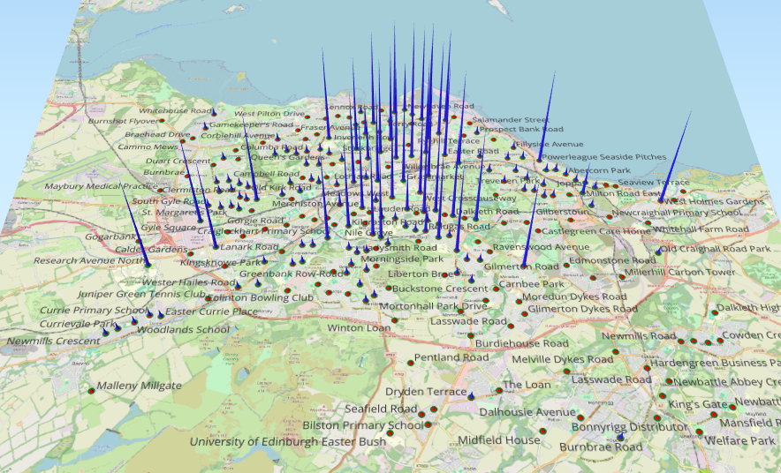

3.1.1 Sensitivity Analysis
In the solving of this problem we were able to identify two major binding constraints for our model, budget and minimum coverage requirements. A sensitivity analysis was carried out on these constraints to identify possible future adjustments to the deployment of the scheme.
The budget was a clear binding constraint even prior to running the model. As mentioned previously we had generated our proposed budget based on a average of a range of possible budgets. This analysis was also carried out with the minimum coverage constraint enforced and with it completely relaxed, leading to the graphs below. The budget was tested on a range of £1,750,000 - £8,8250,000 increasing in increments of £500,00. The lower bound was selected as the initial cost of the historic scheme, the upper bound is the point in which our model reaches its maximum possible coverage based on its formulation with minimum coverage enforced.
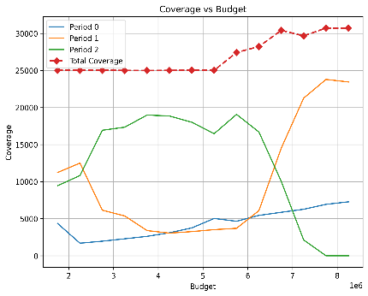
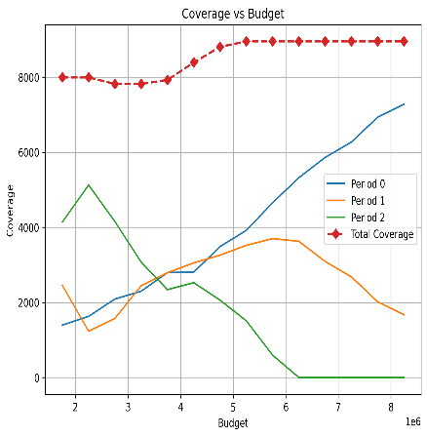
Figure 1: Sensitivity Analysis of Budget (left: constrained, right: unconstrained)

In both cases raising the budget does eventually lead to an increase in total coverage before eventually plateauing. This is exactly as would be expected from the model as initially greater investment will be funnelled into the higher value stations, increasing their capacity.
In the constrained analysis the model will then push for maximum coverage. Period 0 reflects a general upwards trend at a low rate as this is the initial investment period with no degradation in value. Period 1 does see a slump in the mid-range budgets before beginning to climb. This is likely because whilst the budgets are below a certain threshold focus is still on increasing the capacity of the valuable stations before increasing coverage when there is not substantial excess funding. Period 2 experiences an opposite trend to Period 1, even hitting zero at the highest budgets, this is likely as the degradation factor effect on investment value can only really be avoided if it is possible to build all the stations in earlier periods.
In the unconstrainted model, we see a similar relationship between Period 1 and Period 2. However, period 1 experiences a fall off whilst Period 0 increases more sharply and to a higher degree. This can be explained by an examination of the total coverage where we can see that this never reaches close to the theoretical maximum based on POI coverage. Indicating that the value of the busiest and highest POI density station is such that without the model being forced to increase its coverage it determines that increasing the capacity of such stations vastly outweighs benefit of increasing the total coverage. This follows as more people will benefit in the higher population/trip density areas of the city.
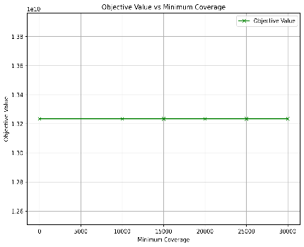
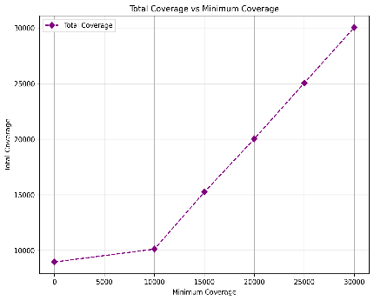
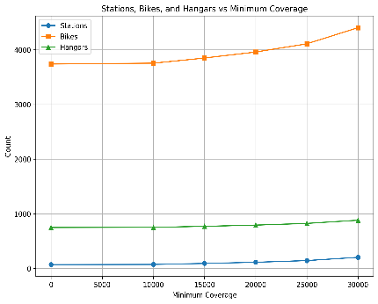
The analysis of minimum coverage was carried out with the budget constraint enforced and relaxed.
Figure 2: Sensitivity Analysis of Minimum Coverage (Budget Constrained)
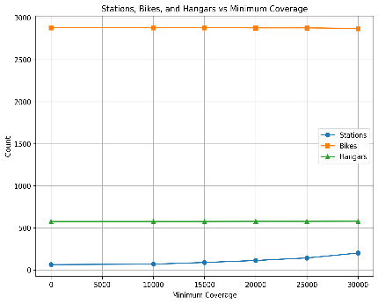
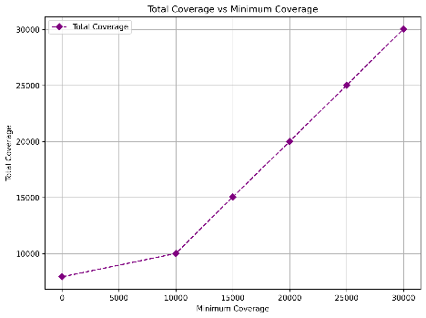
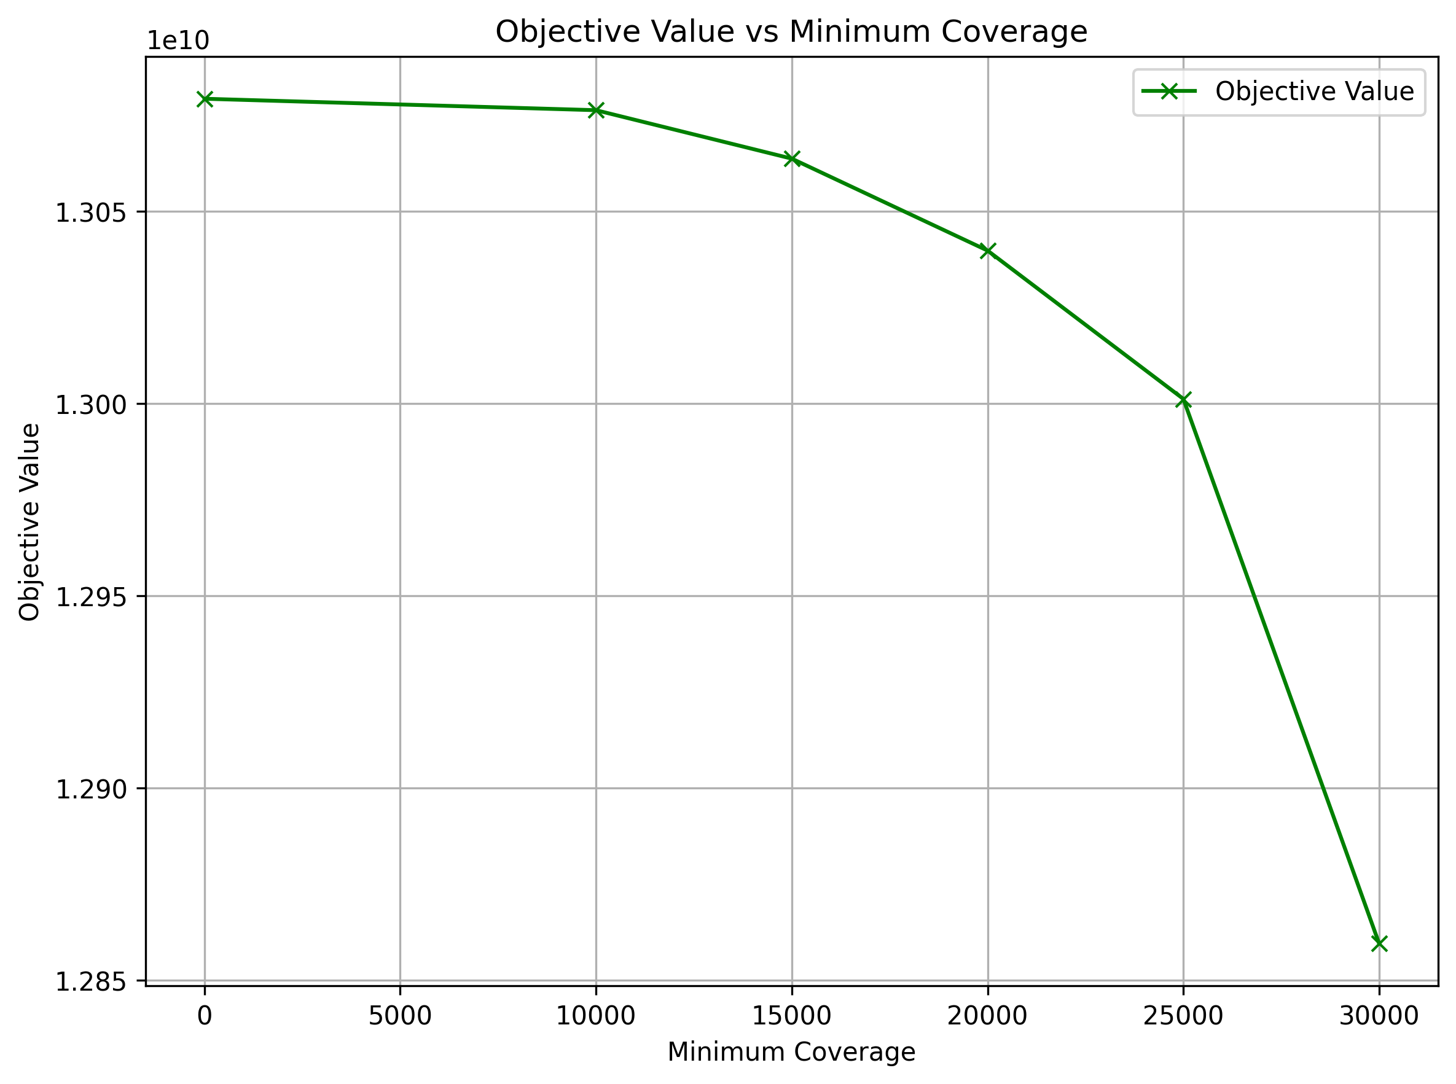
Figure 3: Sensitivity Analysis of Minimum Coverage (Budget Unconstrained)

From the first set of graphs it can be seen that, while budget is constrained, minimum coverage does not have any significant effect on the objective value and the coverage is maintained at the lowest possible amount. This likely happens from the model balancing the coverage requirements against investment in high value stations to ensure that there is no drop off in the social value of the project.
In the second set of graphs, if budget is unconstrained then forcing a minimum coverage results in a large drop off in objective value. We can understand this through the analysis of budget that the model strongly prefers to invest in a few high value stations as the impact the most number of people so forcing to increase coverage draws investment away from these stations.
Based on both sets of sensitivity analysis we could recommend that an increase in budget is preferable. It could also be said that based on current parameters that aiming for maximising coverage is detrimental. However, it must be noted that the model does not consider factors such as lack of bus services, benefit of cutting journey times and increasing journey flexibility through the use of e-bikes. So, we still strongly urge the stakeholders to aim for maximum coverage especially in the more realistic case of having a constrained budget.

3.2 Extended Model

3.3 Maintenance Tool
Provided in Appendix # is a mock-up of a maintenance forecasting and scheduling tool developed to enable long term maintenance activities to be planned effectively. This tool is modular and can be updated to accommodate changes to bikes allocated to each station and changes in number of stations open. The tool allows you to dynamically filter to see how many bikes are at any given station, how many maintenance hours, by category, are needed for each station. Furthermore, the tool has the basis for annual scheduling by station to allow planners to schedule maintenance around demand windows, especially seasonal fluctuations. Such scheduling is essential to ensure the highest quality product while maximising bike availability while being flexible enough to allow for unexpected events resulting in the need to remove bikes for critical maintenance.

4 Conclusion
E-Bike Edinburgh provides a proven system capable of reducing traffic and CO2 emissions while providing an effective alternative to existing public transportation infrastructure. The bike rental scheme will provide an option to health-conscious commuters for daily travel at low cost to the council. The scheme also provides the opportunity for companies to contribute as part of carbon offsetting initiatives. Such contributions could enable the scheme to give special benefits to employees of those companies, such as discounted rates.

5 References
[1] – Edinburgh Cycle Hire, Edinburgh Cycle Hire, Serco, Accessed 10 November 2025
[2] – Road traffic statistics – City of Edinburgh, Road Traffic website - City of Edinburgh, UK Government, Accessed 10 November 2025
[3] – Data Trends Summary, Trends summary, Air Quality in Scotland, Accessed 10 November 2025
[4] – Edinburgh’s net zero target, Edinburgh's net zero target – The City of Edinburgh Council, The City of Edinburgh Council, Accessed 10 November 2025
[5] – Bikehangar, Bikehangar® | Cyclehoop, Cyclehoop, Accessed 17 November 2025
[6] – How much does a lime bike cost to make, how much does a lime bike cost to make - XJD, XJD, Accessed 17 November 2025
[7] – Summary statistics for schools in Scotland 2024, School teachers - Summary statistics for schools in Scotland 2024 - gov.scot, Scottish Government, Accessed 17 November 2025
[8] – Acute hospital activity and NHS beds information (annual), Acute hospital activity and NHS beds information (annual) - year ending 31 March 2024 - Acute hospital activity and NHS beds information (annual) - Publications - Public Health Scotland, Public Health Scotland, Accessed 17 November 2025
[9] – Pupil census supplementary statistics 2024, Pupil+census+supplementary+statistics+2024+-+March.xlsx, Scottish Government, Accessed 17 November 2025
[10] – Annual Libraries Report 2024 to 2025, Annual Libraries Report 2024 to 2025, Department for Culture, Media & Sport, Accessed 17 November 2025
[11] – Our profile, Our profile | Heriot-Watt University, Heriot-Watt University, Accessed 17 November 2025
[12] – Heriot-Watt University Management, Heriot-Watt University Management Team | Org Chart, Heriot-Watt University, Accessed 17 November 2025
[13] – Facts and Figures, Facts and Figures | Queen Margaret University, Queen Margaret University, Accessed 17 November 2025
[14] – Facts and Figures, Facts and Figures, Edinburgh Napier University, Accessed 17 November 2025
[15] – Factsheet of Student Figures, 2023/24, 24.pdf, The University of Edinburgh, Accessed 17 November 2025
[16] – Staff Population Statistics, Staff Population Statistics.pdf, The University of Edinburgh, Accessed 17 November 2025

6 Appendix

